Evaluation: ET-OvR
Accuracy: 0.9077117572692794
Precision: 0.9157458054262182
Recall: 0.9077117572692794
F1 Score: 0.9086702808581325
Jaccard Index: 0.8357781832505634
Matthews CorrCoef: 0.8831865895778617
Cohen’s Kappa: 0.8813047169365299
Specificity: 0.9860088070715026
AUC: 0.9997848845547112
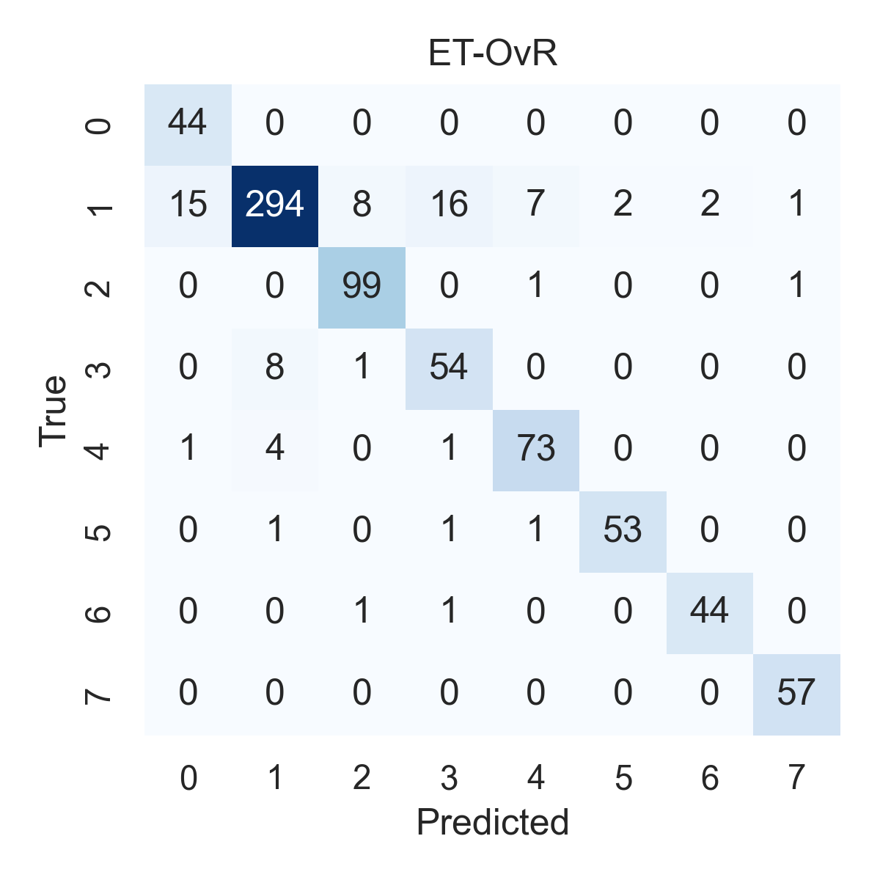

Combined ROC Curves
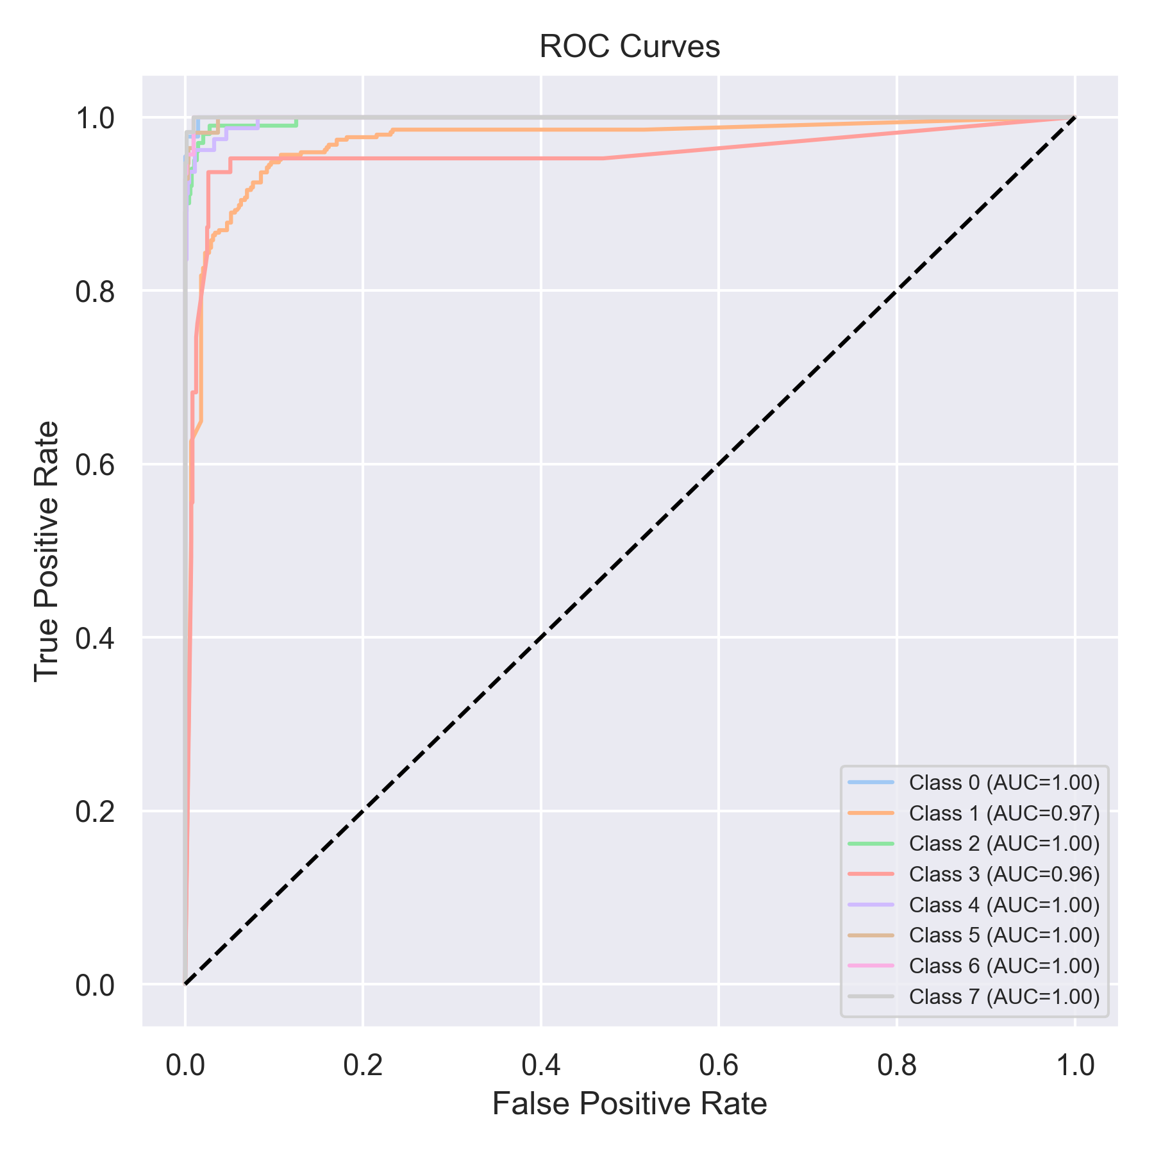

Evaluation: RF-OvR
Accuracy: 0.8862199747155499
Precision: 0.9031167731062945
Recall: 0.8862199747155499
F1 Score: 0.8872099298758194
Jaccard Index: 0.8003170144425804
Matthews CorrCoef: 0.860752891214994
Cohen’s Kappa: 0.8558778514685519
Specificity: 0.9836237379699055
AUC: 0.999665375973995
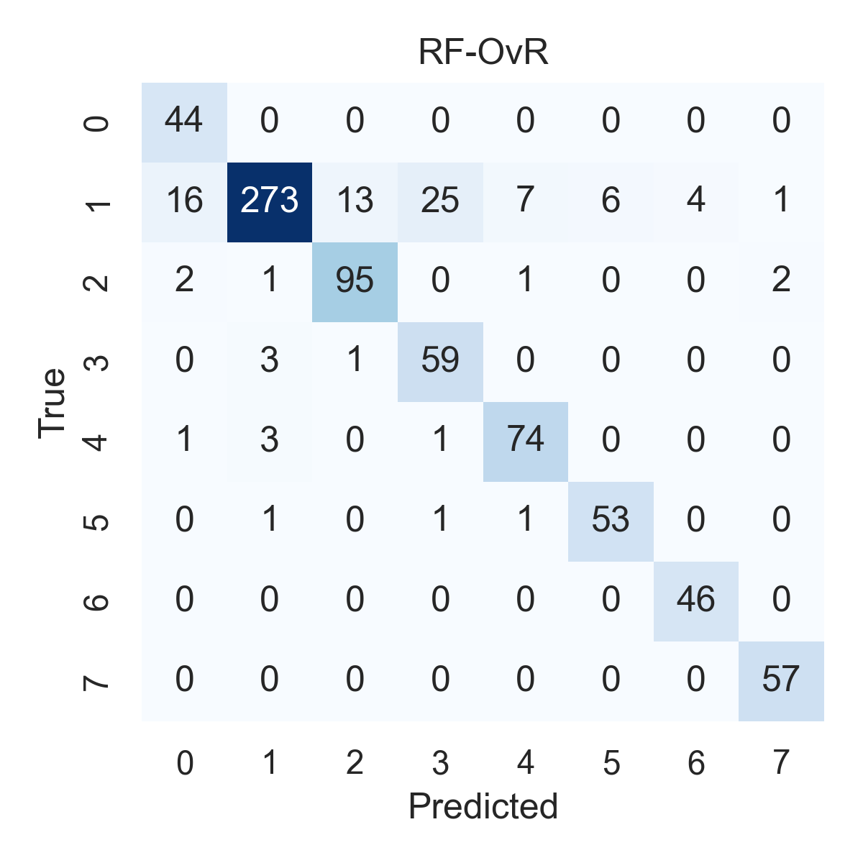

Combined ROC Curves
